Aerial Yoga Teacher Training Modules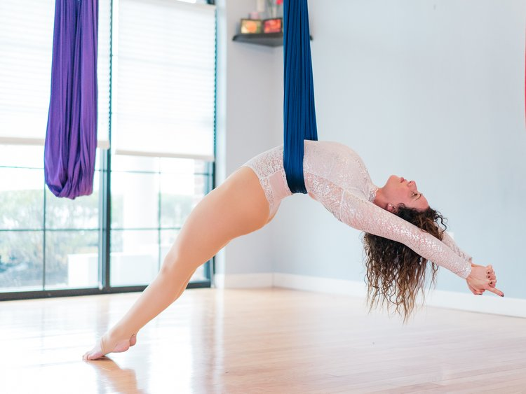

Led & Created by Jodi Kobrin, Co led by Jana VK

HISTORY & PHILOSOPHY
Fly deep into the history, foundation & philosophy of aerial, yoga, yoga sutras, yamas & niyamas for the modern fly yogi.
ALIGNED FLY METHOD
Asana study & the functional teachings of the Fly & Release Method help you deepen your connection to your practice.
ART OF TEACHING
Unlock your potential with Fly + Release cues, knowledge, tools & hands-on practical work to build your voice as a teacher. Our format allows you to shine.

PRANAYAMA & MEDITATION
Learn basic pranayama and meditation techniques to enhance your practice and teachings.
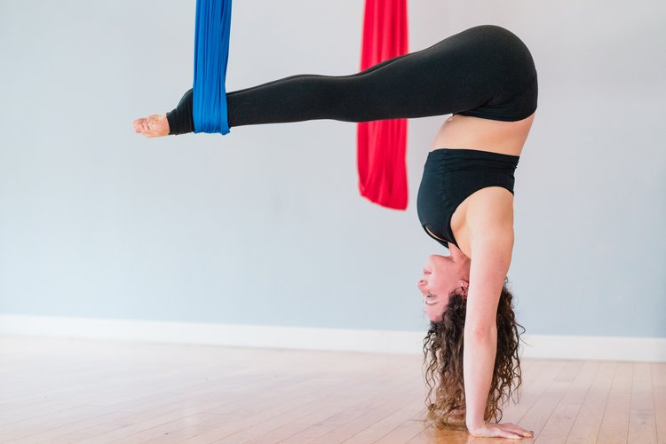
ALIGNMENT
Learn the foundation and principles of the placement of the body within the posture and how that translates to your own body.

SEQUENCING
Learn the art of intelligent & mindful sequencing and how to make your classes unique and inspiring.

ANATOMY FOR AERIAL & YOGA
Hands-on practical approach to the study of anatomy for yoga to give you a solid understanding for your practice and teaching.
SUB-STYLES OF YOGA
Get an intro to sub-styles of yoga that complement the FLy + Release Method (yin, restorative, etc)
MAGIC CARPET
Off-site excursions to experience, explore & play balanced with the art & act of giving back to local foundations that support the community.
MARKETING & YOGA BUSINESS
Learn how to take what you’ve learned and share it with the world in a way that’s authentic, mindful and sustainAble.
JOIN THE #FLYSQUAD TRIBE
Emerge with the knowledge that you will always have a home, build lifelong bonds & graduate in the company of other inspiring flyers..

